  - 891,897,902,918,934,946,960,961,978,1010,1018,1062,1070,1087,1099,1188,1238,1356,1427
A,C,C,A,C,A,C,U,A,C,C,C,A,A,U,A,U,U,U
      - Cascade – 2,3,5,7,10,11,12 total=50
      - Airfit – 1,4,6,9,13,14,16 total=63
      - Ultralite – 8,15,17,18,19 total=77
H=$\frac{12}{19\left(20\right)}\left(\frac{{50}^{2}}{7}+\frac{{63}^{2}}{7}+\frac{{77}^{2}}{5}\right)-3\left(20\right)=6.6297745$
  - $\frac{18!}{7!7!5!}=39907296$ permutations of ranks
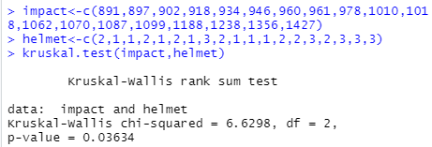

  - pKW(impact,helmet,method="Monte Carlo",n.mc=1000000)
Group sizes: 7 7 5
Kruskal-Wallis H Statistic: 6.6298
Monte Carlo (Using 1e+06 Iterations) upper-tail probability: 0.029
  - The Kruskal-Wallis test assumes that the population distributions of the different treatments have the same form F_{j}(t) = F(t – τ_{j}). The data appears to violate this assumption when looking at the histograms for each sample.

  - At alpha level = 0.15, there is enough evidence to reject the null hypothesis and conclude that the true median rear impact force is not the same for all 3 helmet designs. A follow-up analysis is required to figure out which sample median(s) differ since this only states that at least one is different.
  - $α*=\frac{α}{\frac{k\left(k-1\right)}{2}}→ \frac{0.15}{\frac{3\left(3-1\right)}{2}}=0.05$
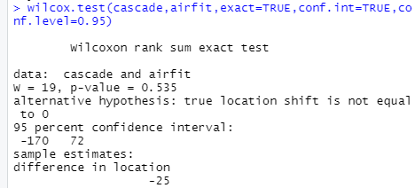
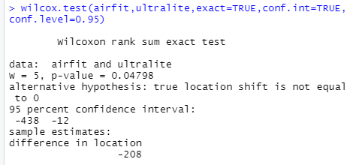

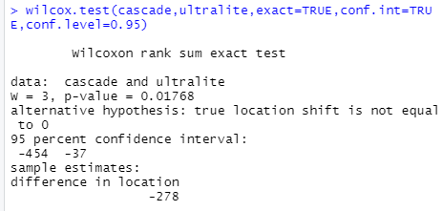

  - The treatment differences that are statistically significant are between cascade-ultralite and airfit-ultralite. We are 85% confident that the median impact force of cascade is between 454 and 37 units lower than the median impact force of ultralite, the median impact force of airfit is between 438 and 12 units lower than the median impact force of ultralite, and the median impact force of cascade is between 170 units lower and 72 units higher than the median impact force of airfit.
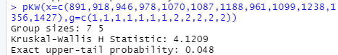
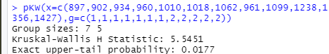

The p-values are almost equivalent to the ones calculated in part (c) which supports that the differences are statistically significant.

